Final build plan
HTML/web requirement | What must be completed by this weekend | Evidence to upload
Main page | The game opens correctly in a browser. | 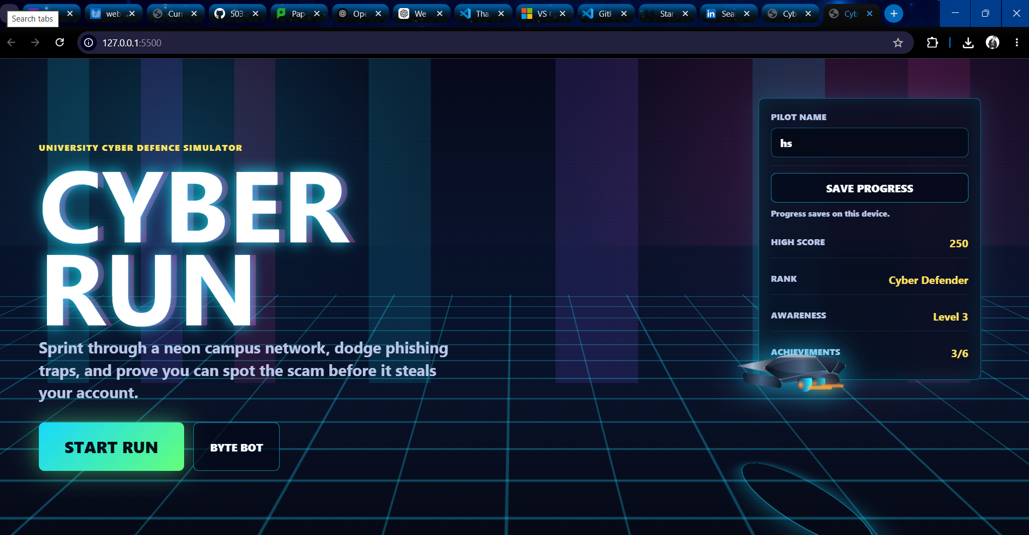
User journey | The player can move from welcome/instruction to challenge and feedback. | 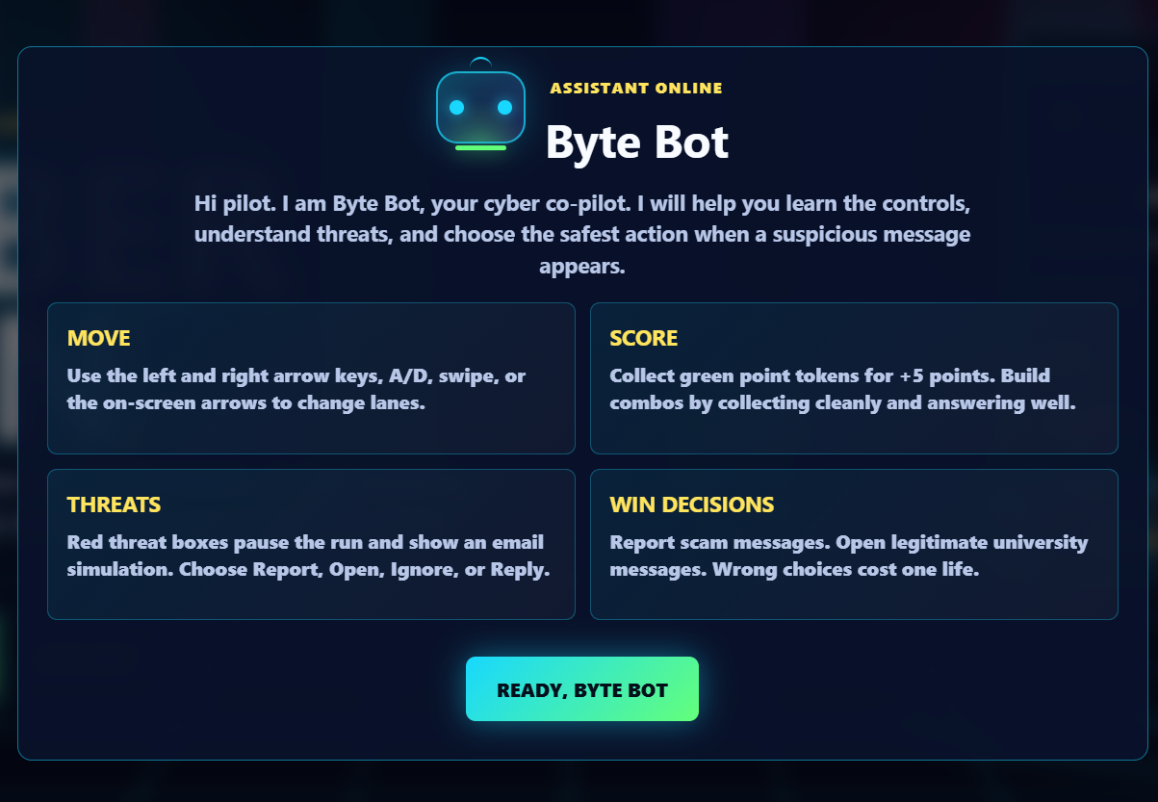  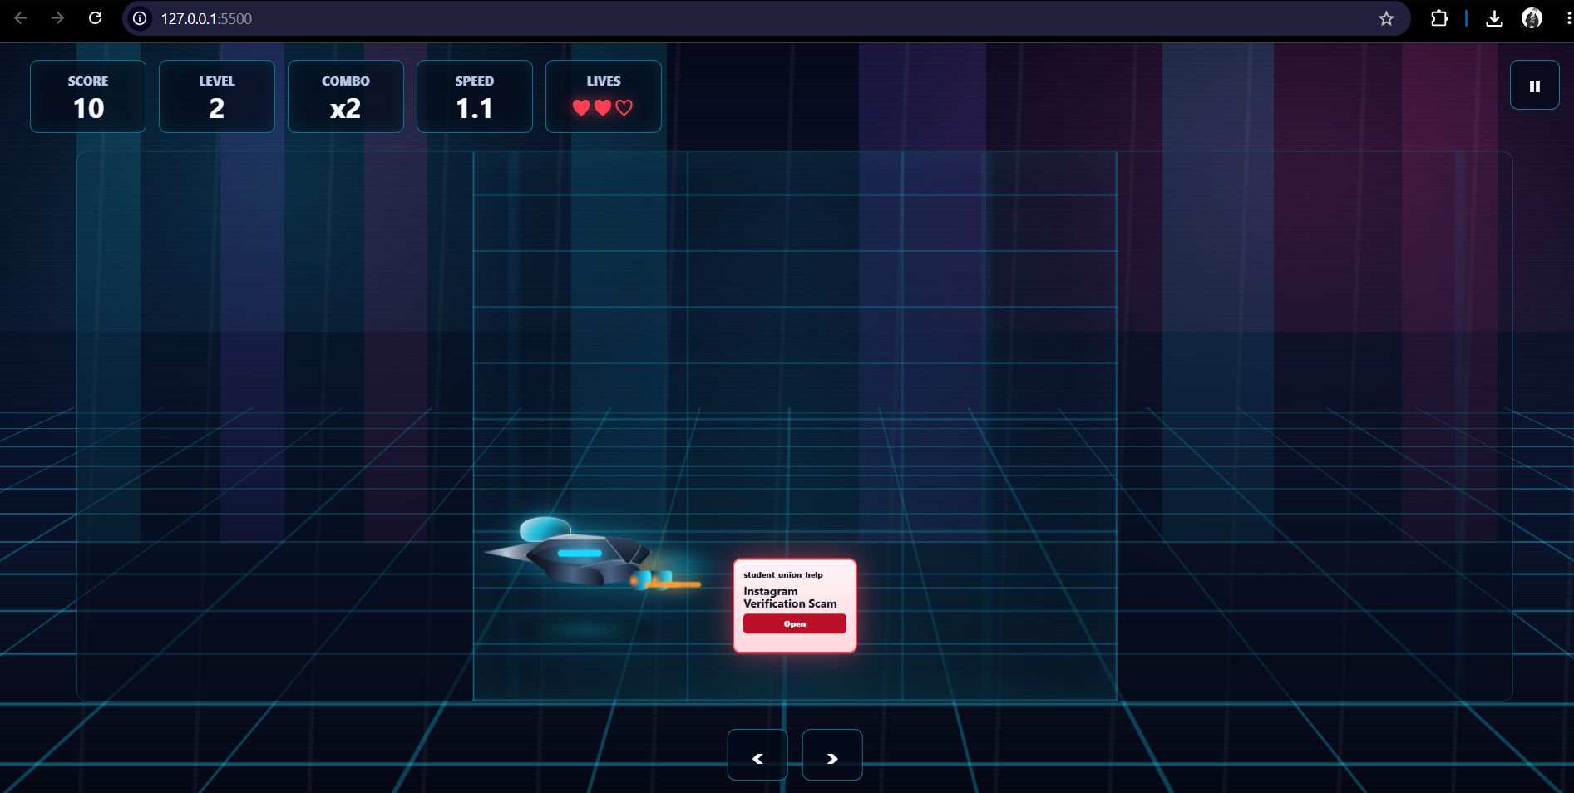
Interaction | Buttons/choices must respond when clicked. | 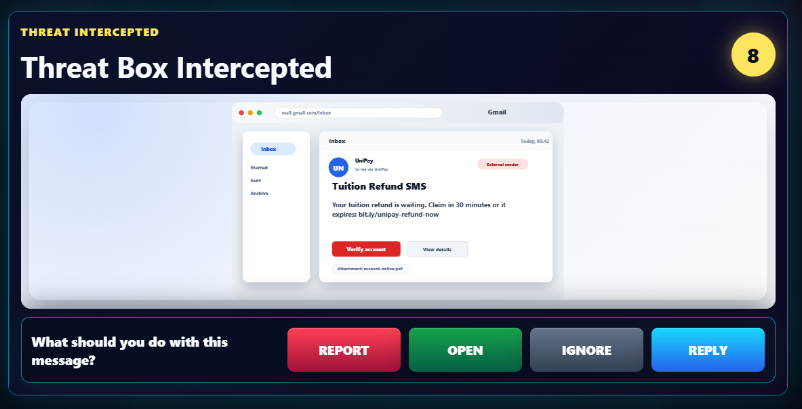
Feedback logic | Correct and wrong choices show appropriate feedback. | 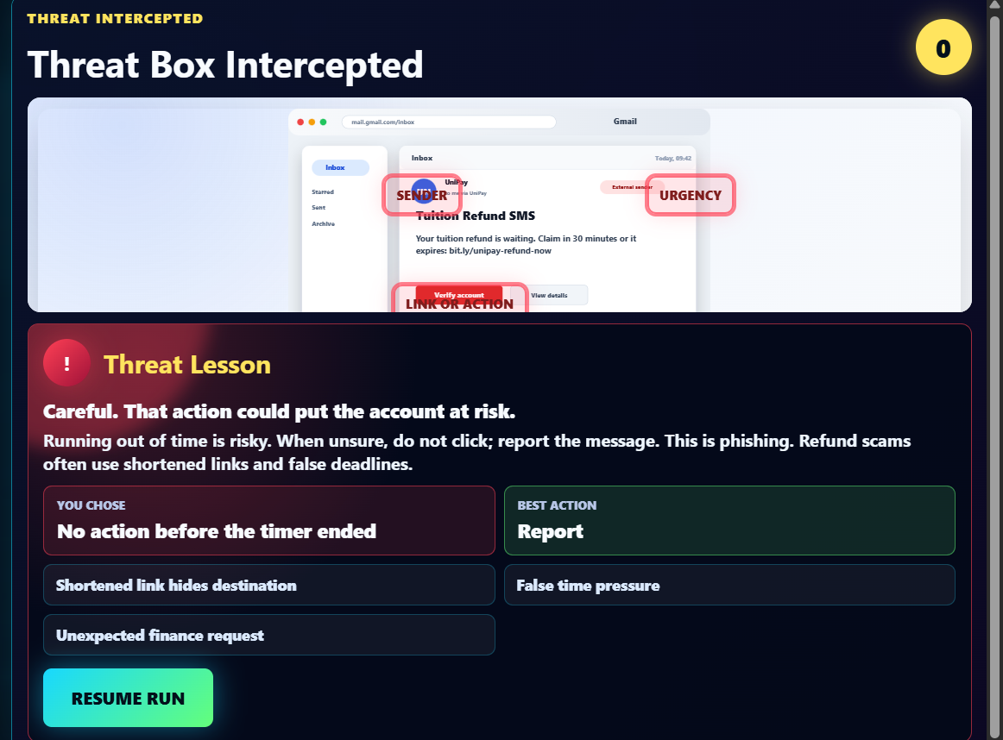  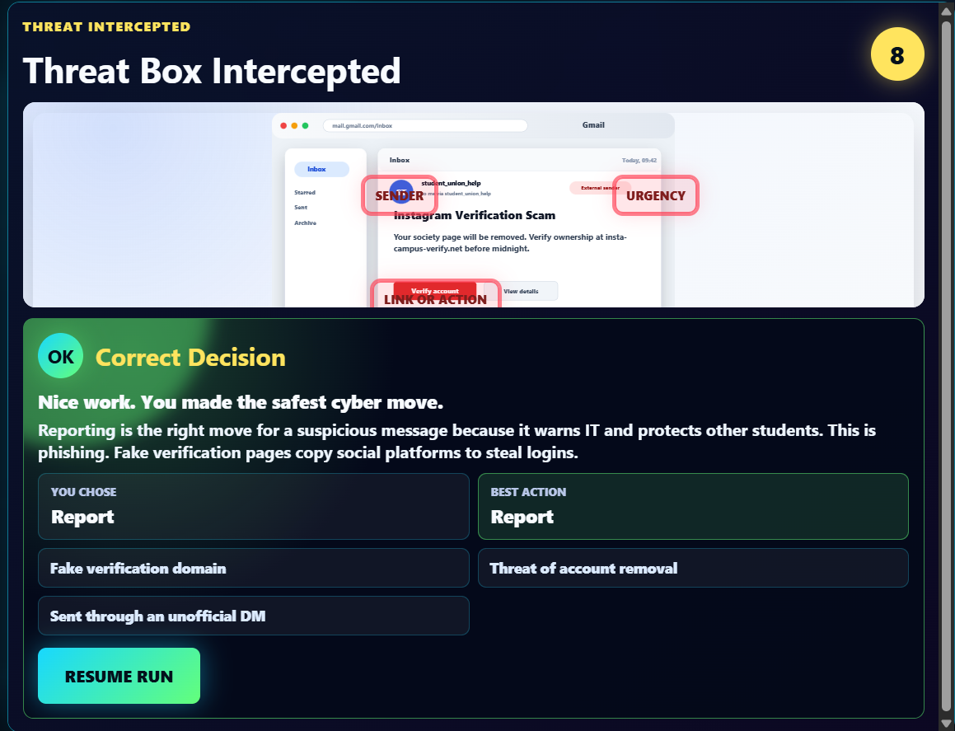
Final files | Upload all actual files needed to run the prototype. If still using one file, upload it. If separated, upload HTML/CSS/JS files. | 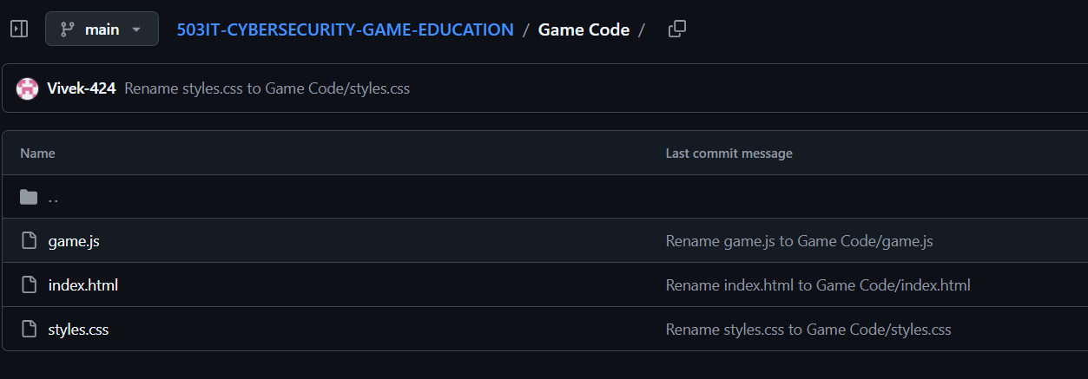  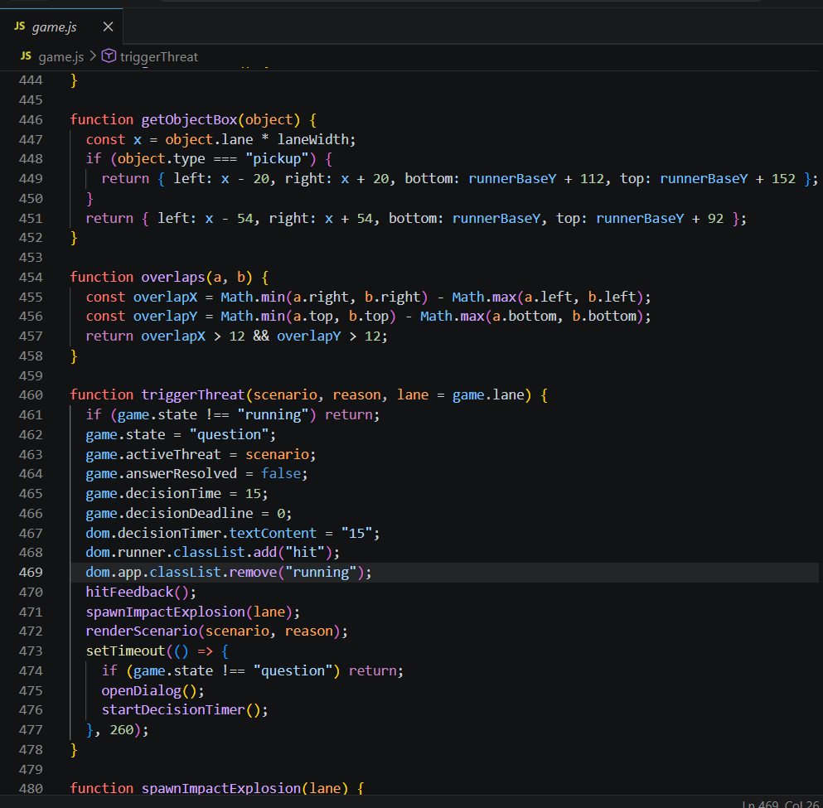  Figure 1 game.js  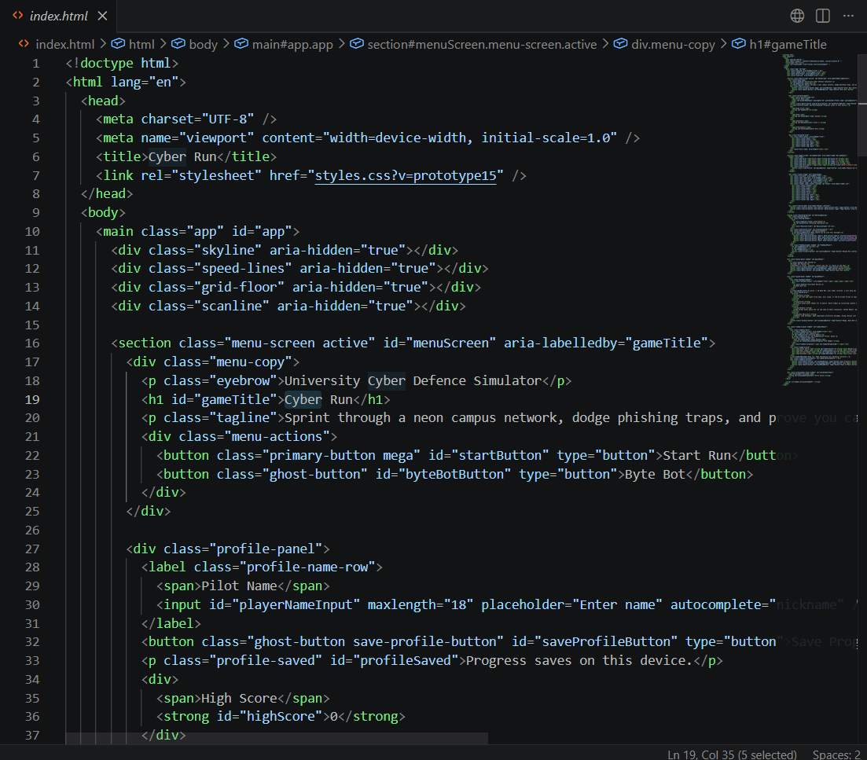  Figure 2 index.html  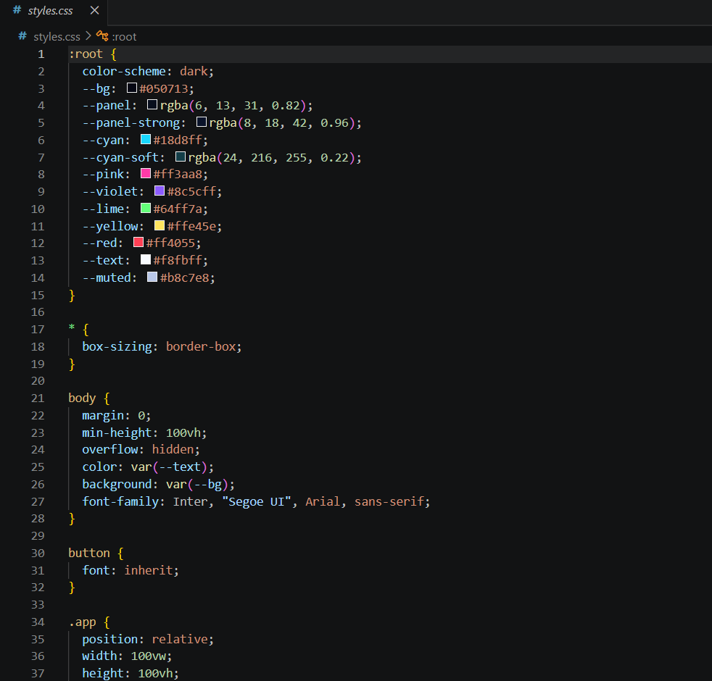  Figure 3 styles.css
Browser testing | Open and test the game in at least one browser. | 